**How to use the automating program**

Riley Delaney - rd167956@hotmail.com

Frank Corapi - fcorapi@edu.uwaterloo.ca

**Start it up**

First, make sure that the motors are plugged in. I.e, the USB is plugged into the black box next to the microscope.

Next, open the matlab code, MMI (found in “Microscope-Motor-Interface” folder on the desktop). There are two MMI files, pick the MATLAB code (MMI.m) one. After that, either click the play button at the top or press F5. This should bring up the GUI for this program.

When the program is running, do not touch the motors or the keyboard/mouse unless a pop up instructs you to. **Do not, under any circumstance, press the F14 or F16 key. :( OR ELSE! GG**

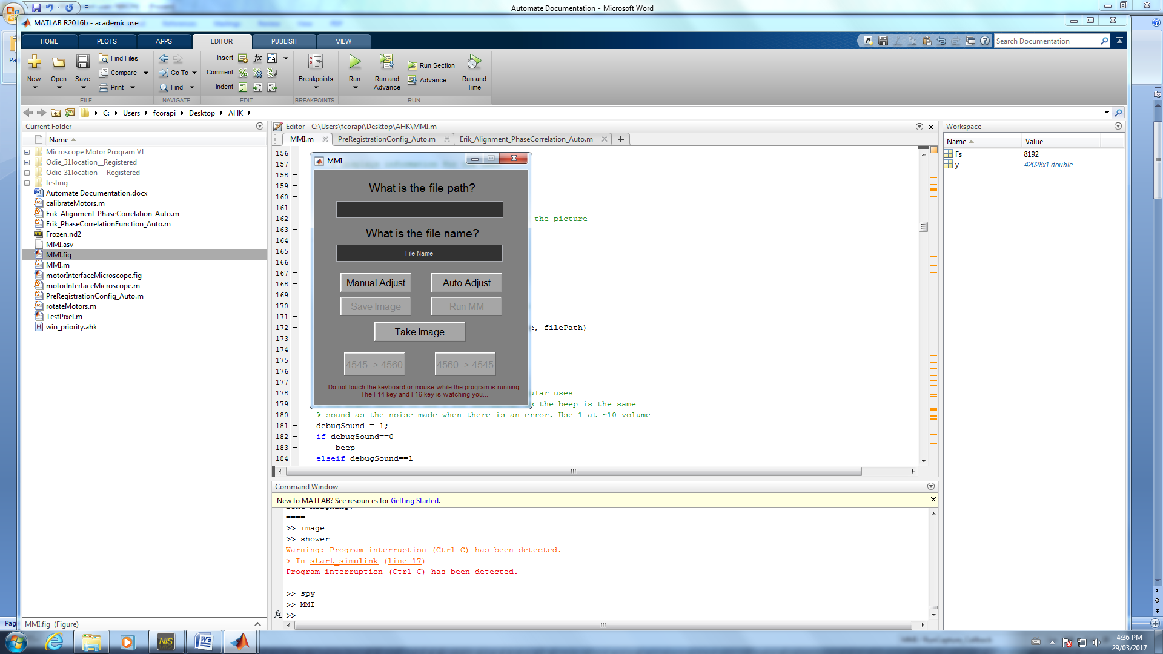

**Input**

File Path - The path where the images will be saved, e.g. "C:\Users\mcampbel\Desktop\test folder\MM". Typing "Current" will save the images in the last folder that picture were saved in (using this will always result in "Path unknown"). Typing "Default" will save the images in "C:\Image dropoff".

File Name - The name of the file. For the MM images, do not include the angles (E.g. do not include 4560). Used for fluorescence, include "mono" or "colour" as needed. Follow the naming convention: subject_quater_location

**Buttons**

Manual Adjust - Manual adjust is still in beta, so do not use it until further notice.

Auto Adjust - Adjusts it to the starting position, 45,60.

Save Image - Saves a single image, use for taking fluorescent images. Use 600ms or less exposure time.

Run MM - Takes and saves all Mueller Matrix images, also aligns the images. Use 30ms or less exposure time.

Take Image - Takes a single image and displays it.

4545 -> 4560 - Goes from 4545 polarizers to 4560 polarizers.

4560 -> 4545 - Goes from 4560 polarizers to 4545 polarizers.

**Save Image**

1. Type the file path and file name into the boxes.
2. If a message box pops up, you are trying to save the picture with the same name as another file. Input a new name into the box and click "OK". If that is the correct name, click "cancel" and delete the other file.
3. Let the program run. Do not touch the keyboard or mouse.
4. Wait for a beep sound and the GUI to pop back up
5. Done

**Run MM**

1. Type the file path and file name into the boxes.
2. Check to make sure that the motors are at 45,60. If they are not at 45,60, click "Auto Adjust"
3. Click "Run MM"
4. If a message box pops up, you are trying to save the picture with the same name as another file. Input a new name into the box and click "OK". If that is the correct name, click "cancel" and delete the other file.
5. Let the program run. Do not touch the keyboard or mouse.
6. When a beep sound and a message box pops up, remove the motors from the microscope and click "OK". Now, you can look at the images and/or look for another deposit. Do not touch the motors while they are calibrating.
7. Once the motors are done moving, another beep sound will happen.
8. Check to makes sure that the images are aligned

**Issues and What They Look Like**

'Frozen' or 'Capture' images. This is because the hotkey program momentarily runs faster than NIS Elements, this error should not occur, unless the exposure time is too high or too many images are opened in NIS Elements. If this occurs, delete all the files and run the MM again.

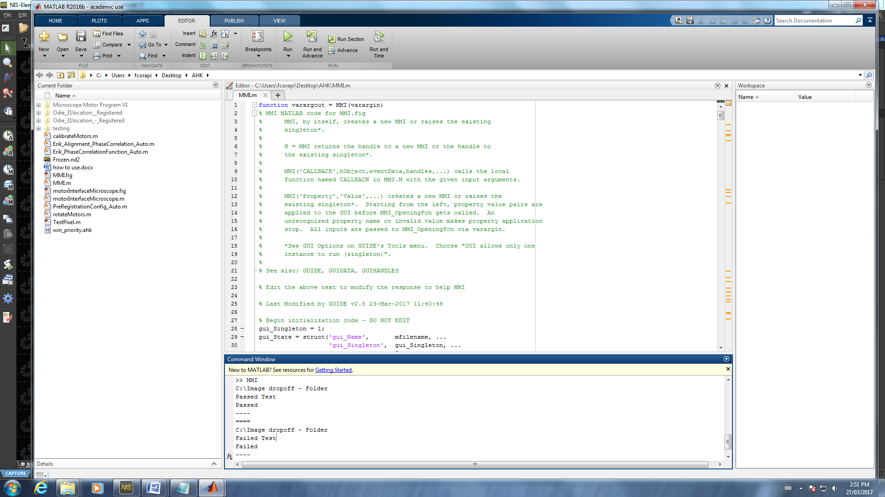

If two "frozen" files try to save, it will alternate between trying to override and renaming. This is a controlled error, however, no images afterwards will be save. Either let the program end or when the motors are turning, go to the command window and use control-c. After this restart Matlab and do not save the Matlab file when closing it.

If you try to save while NIS Elements is in another window then live mode, such as save as window, close it down the window if possible (when the motor is turning). Then do either of the solution above. This is not a controlled error, it has different effects depending which window in NIS Elements is open.

Wrong file type. This most likely happened if the mouse is moved when the hotkey program is changing to either .bmp or .nd2. You will need to delete all the files and rerun the program.

Misaligned. If the images are not properly aligned, it will need to be aligned using Erik's main program, not the modified one used in this program. Erik's code and documentation can be found in "Y:\shared\Erik Alignment Code".

If the program does not leave the GUI, make sure "win_priority.ahk" is running. If it is not, go into the Microscope-Motor-Interface folder and double click "win_priority".

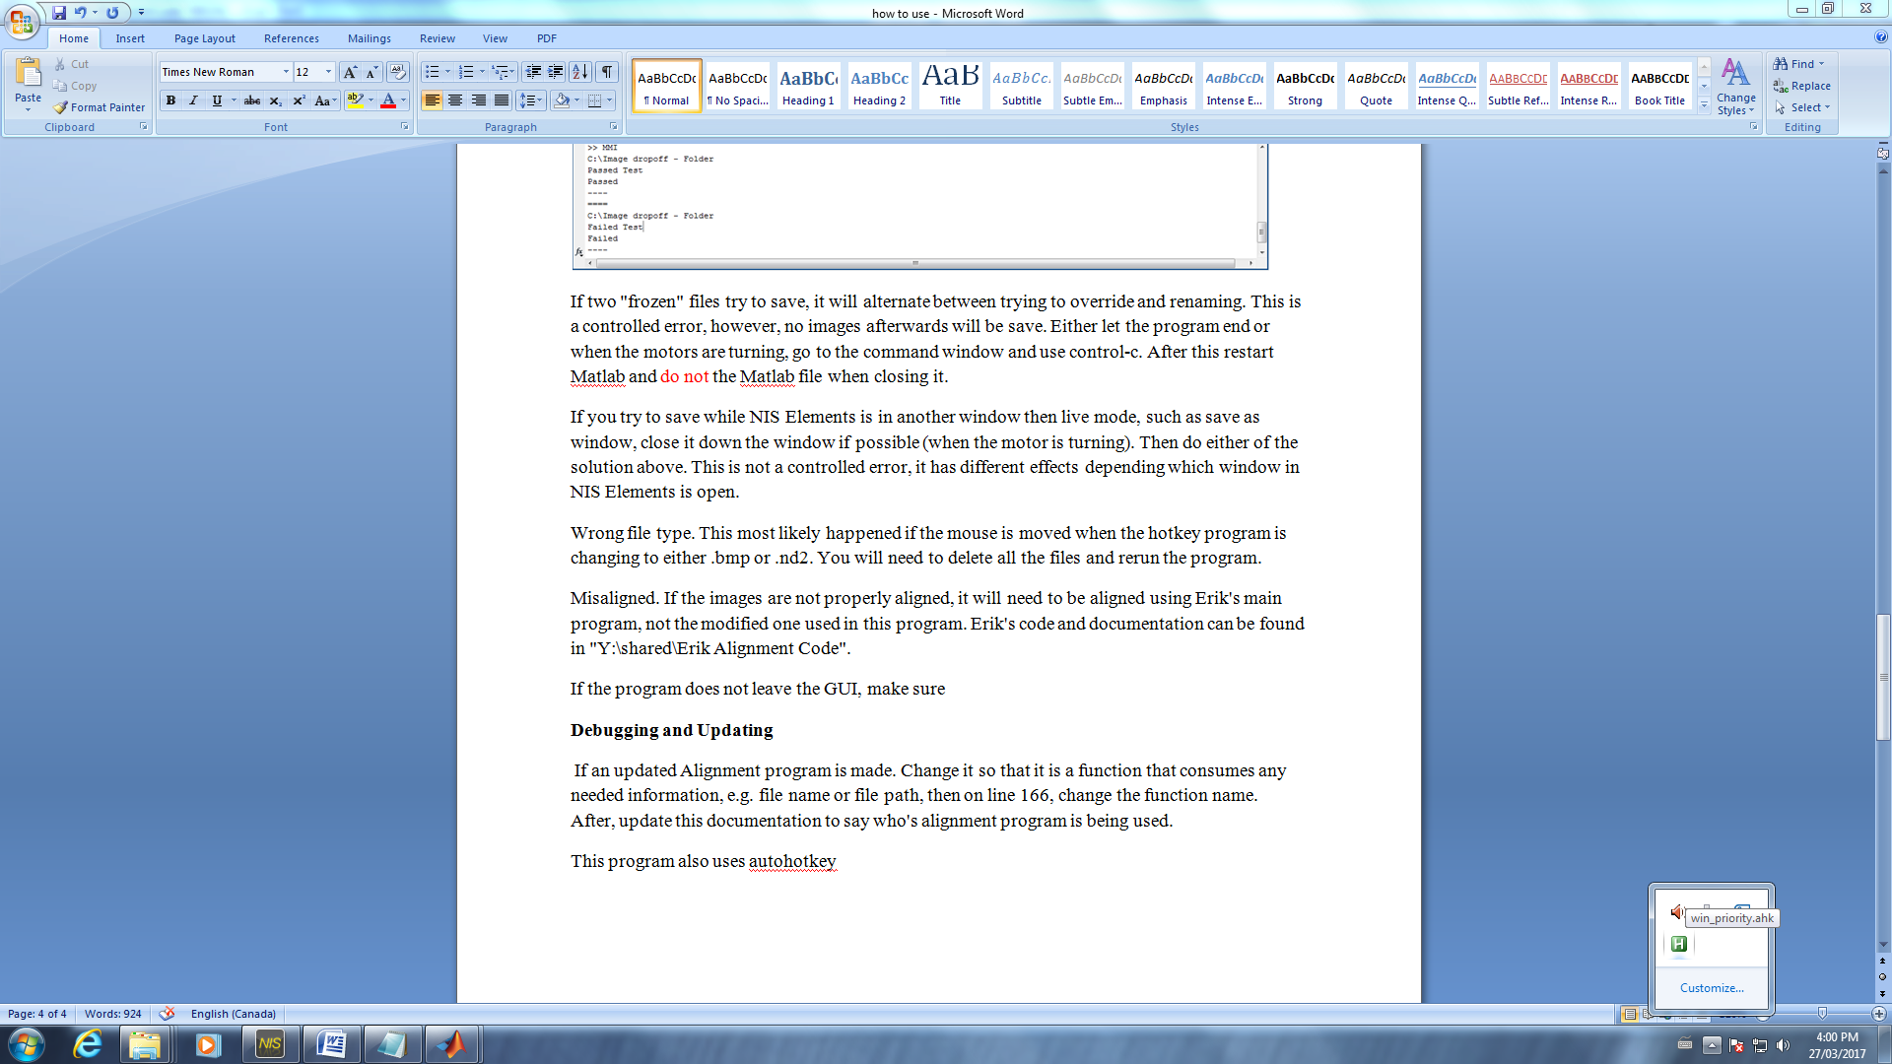

**Setting up a New User**

Download, or transfer, GitHub onto the new user. Sign into GitHub with the [f16key@hotmail.com](mailto:f16key@hotmail.com) account with the password donotpressf16. Clone the folder onto the new user.

Press win-r (windows r) to bring up run. Type in "shell:startup" to bring up the folder that runs programs on start up. Lastly, put a shortcut for "win_priority.ahk" into that folder. This will make "win_priority" run each time the user is started up.

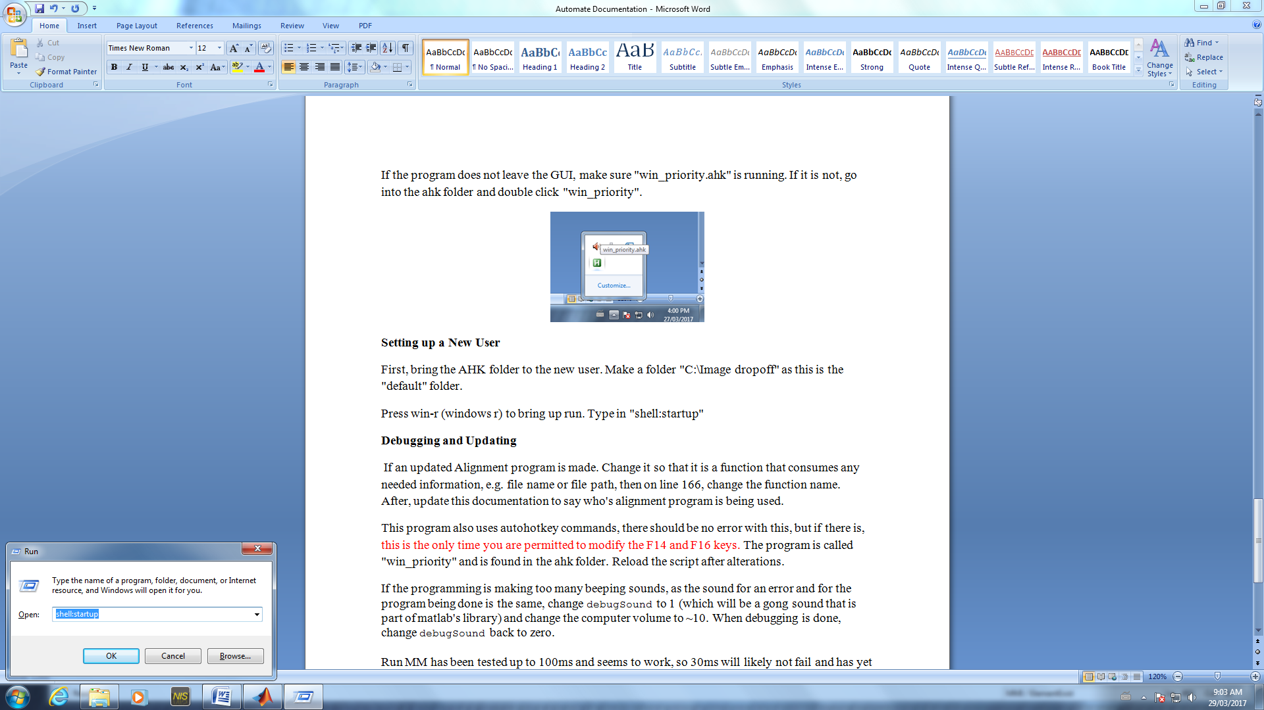

Now, the program should run properly.

**Debugging and Updating**

Edit the code on the cloned version and then when all your edits are done, save and then make a pull request.

If an updated Alignment program is made. Change it so that it is a function that consumes any needed information, e.g. file name or file path, then on line 166, change the function name. After, update this documentation to say who's alignment program is being used.

This program also uses autohotkey commands, there should be no error with this, but if there is, this is the only time you are permitted to modify the F14 and F16 keys. The program is called "win_priority" and is found in the Microscope-Motor-Interface folder. Reload the script after alterations.

If the programming is making too many beeping sounds, as the sound for an error and for the program being done is the same, change debugSound to 1 (which will be a gong sound that is part of matlab's library) and change the computer volume to ~10. When debugging is done, change debugSound back to zero.

Run MM has been tested up to 100ms and seems to work, so 30ms will likely not fail and has yet to fail. Save Image has been tested up to 1s and seems to work without fail, so 500 ms will likely work without fail. Exposure time up to the testing values should work, but are not encouraged to be used.